Alexander Baldree
Module 9.2 Assignment
09/26/26
CSD440

Github Link:
https://github.com/Panda-Alex21687/CSD440

Index page:
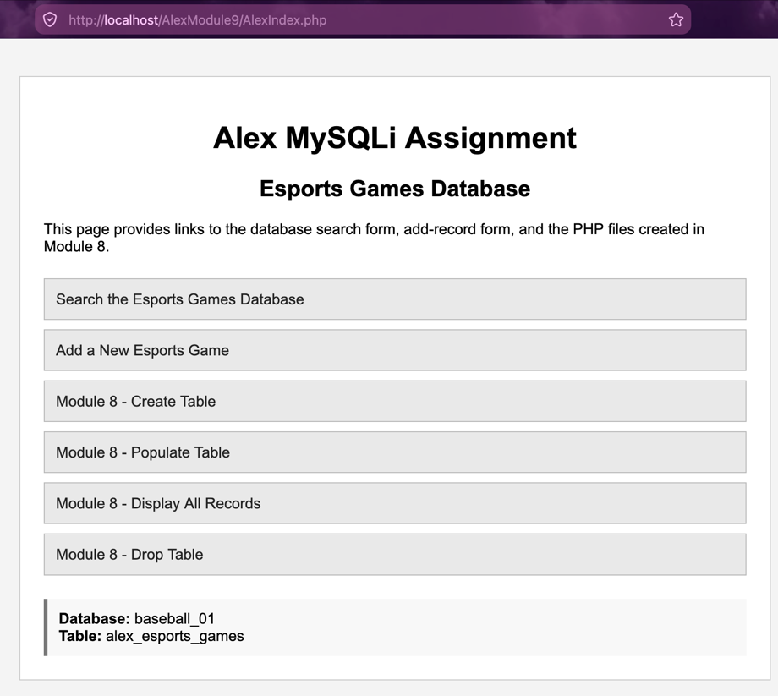

Query/Search Form:
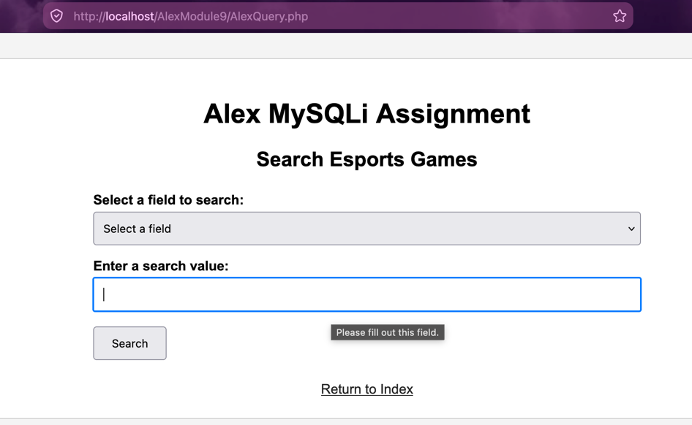
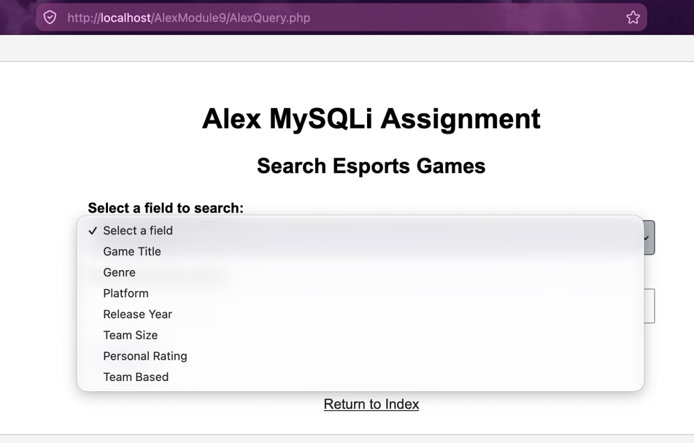

Query Results:

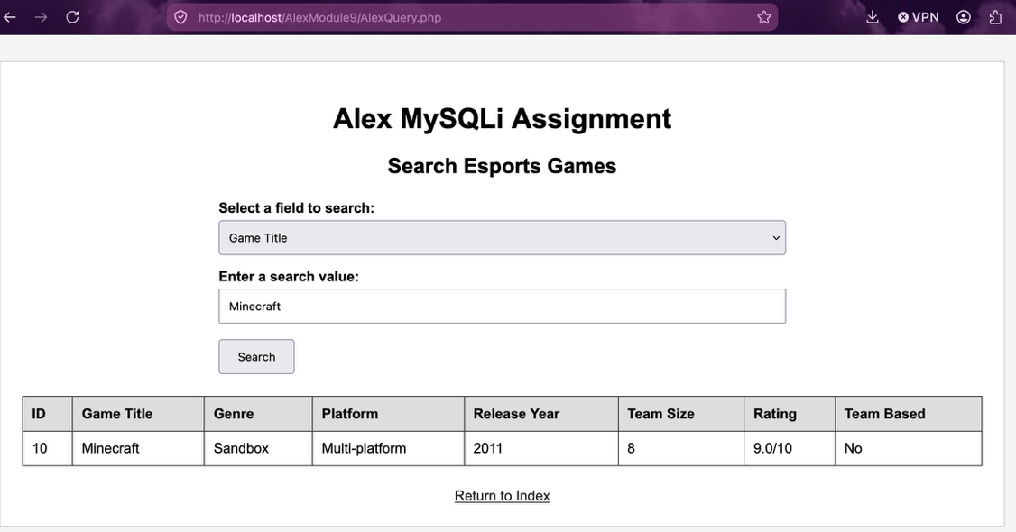

Record Form:
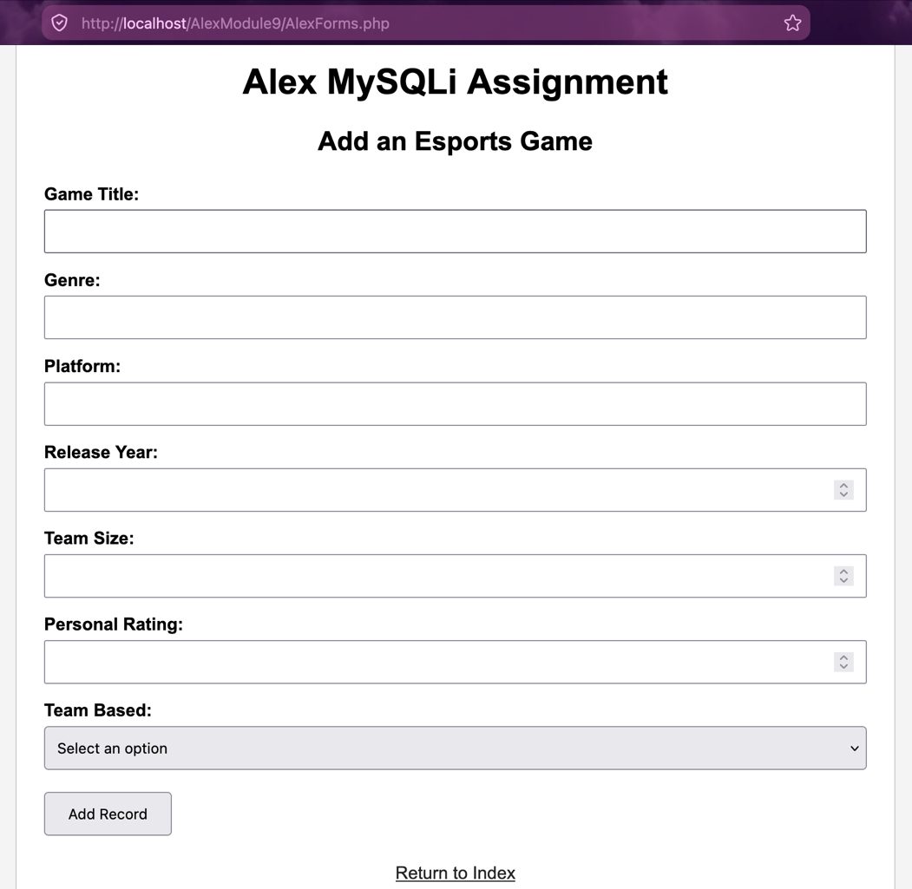

Added Record/ Database:
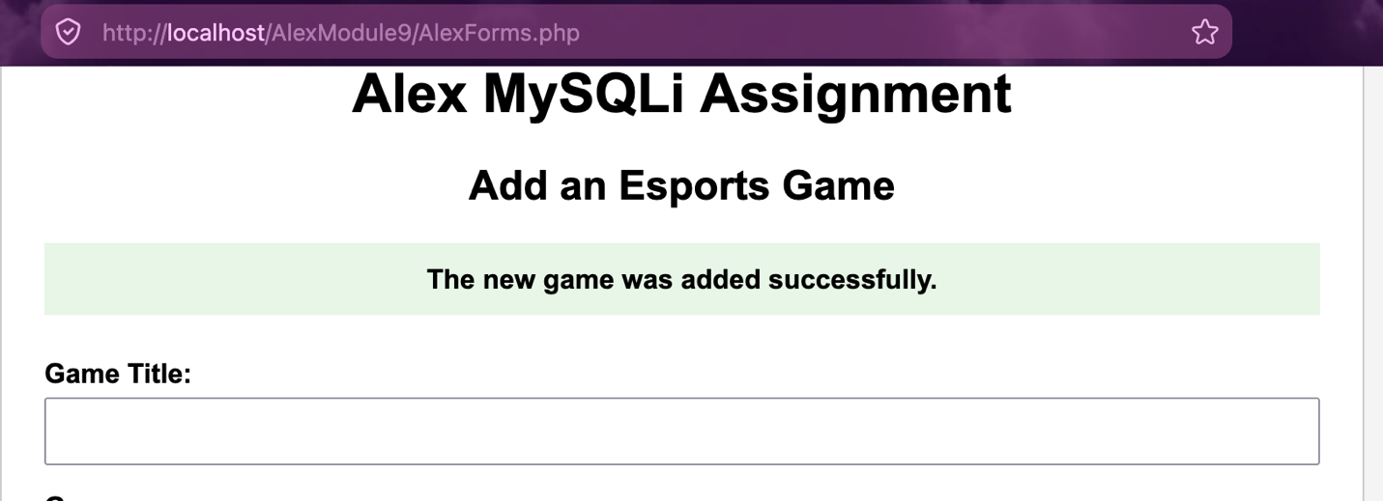

Test confirmed Added:
